Project Planning Phase
Project Planning Template (Product Backlog, Sprint Planning, Stories, Story points)
Date | 01 October 2026
Team ID | ________________
Project Name | Implement Client Script & UI Policy (Incident)
Maximum Marks | 5 Marks
Product Backlog, Sprint Schedule, and Estimation (4 Marks)
Use the below template to create product backlog and sprint schedule.
Sprint | Functional Requirement (Epic) | User Story Number | User Story / Task | Story Points | Priority
Sprint-1 | Incident Configuration | USN-1 | As an administrator, I can create the High Impact Control UI Policy so Incident fields respond dynamically to Impact. | 3 | High
Sprint-1 | Incident Configuration | USN-2 | As an administrator, I can configure the Urgency UI Policy Action so Urgency becomes read-only for High Impact incidents. | 2 | High
Sprint-1 | Incident Automation | USN-3 | As an Incident user, when Impact is High, Urgency is automatically set to High. | 3 | High
Sprint-1 | Incident Validation | USN-4 | As an Incident user, a High Impact Incident cannot be saved when Assigned To is empty. | 3 | High
Sprint-2 | Reverse Behaviour | USN-5 | As an Incident user, when Impact changes from High to Medium, the High Impact UI Policy behaviour is reversed. | 3 | Medium
Sprint-2 | List Protection | USN-6 | As an Incident user, I cannot change State directly through list editing. | 3 | High
Sprint-2 | Testing & Evidence | USN-7 | As a project team, we can verify successful save behaviour and capture evidence for the configured controls. | 3 | High
Sprint-2 | Testing & Evidence | USN-8 | As a project team, we can document functional test results for all implemented Incident controls. | 3 | High
Team Members: Vishnu Raj, Lokeshwaran, Sandeep, Gowtham, Arun Allwin Raja

Project Tracker, Velocity & Burndown Chart: (4 Marks)
Sprint | Total Story Points | Duration | Sprint Start Date | Sprint End Date (Planned) | Story Points Completed (as on Planned End Date) | Sprint Release Date (Actual)
Sprint-1 | 11 | 6 Days | 21 Sep 2026 | 26 Sep 2026 | 11 | 26 Sep 2026
Sprint-2 | 12 | 6 Days | 28 Sep 2026 | 03 Oct 2026 | 12 | 03 Oct 2026
Velocity:
Velocity is the amount of completed story-point work achieved by the team per sprint. For this project, two planned sprints contain 23 total story points.
Total Story Points = 23 | Number of Sprints = 2 | Average Velocity = 23 / 2 = 11.5 Story Points per Sprint
The planned team velocity for this project is 11.5 story points per sprint based on the project planning estimate.

Burndown Chart:
A burndown chart is a graphical representation of work left to do versus time. For this ServiceNow project, the chart tracks the remaining planned story points across the two development sprints.
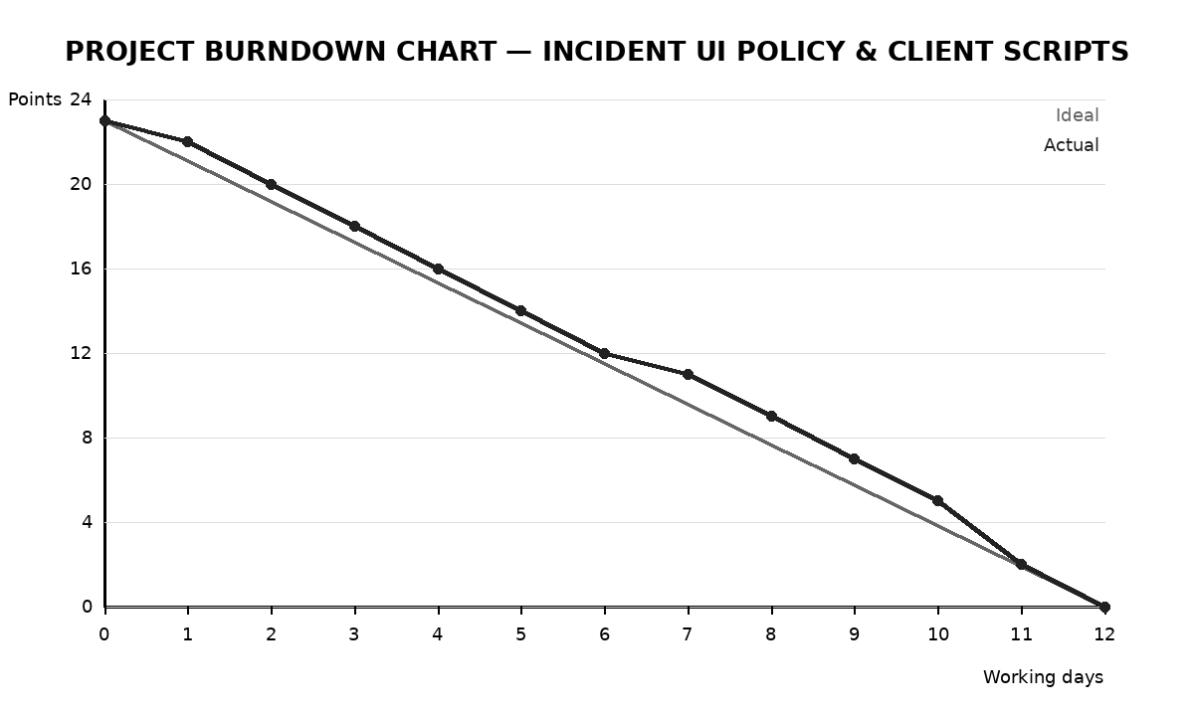
The chart uses a planned starting workload of 23 story points and tracks the remaining work down to zero. The actual line represents the project work sequence used for the Incident UI Policy and Client Script implementation.
Planning Logic:
Sprint = a fixed period in which the team works to complete a set of tasks. Epic = a larger functional requirement broken into smaller stories. Story = a small task that forms part of an Epic. Story Point = a relative estimate of the effort required to complete a story.
Story-point scale used: 1, 2, 3, 5.

